An Overview on the Reciprocal Determinism Concept With Examples
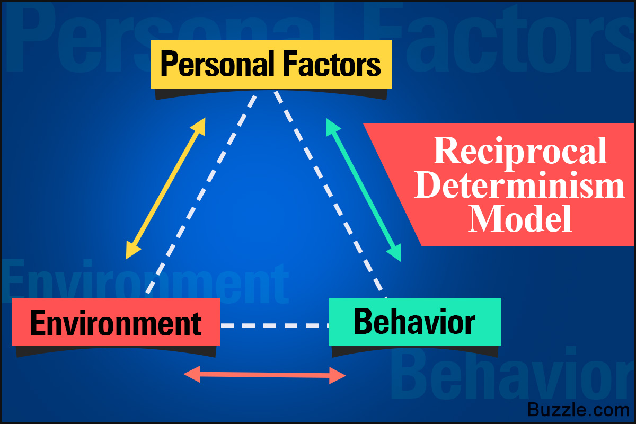
Albert Bandura put forth the concept of reciprocal determinism, which purports that not only does the environment influence the person, but the person also brings about a change in the environment.
Music and Moods
Loud music like heavy metal is believed to put a person in an agitated state of mind, whereas soothing music enables the person to take decisions in a calm and rational manner.
Have you ever wondered what makes us behave the way we do? Why we like to catch up with our friends after work, or get irritated at being stuck in traffic? For many, these 'questions' may not even seem like something that needs to be thought about. They may just be a part of normal behavior. However, have you ever given a thought to what drives our behavior, and about its subsequent consequences? This is exactly what the theory of reciprocal determinism explains.
An Overview of the Theory
Albert Bandura, a renowned psychologist, put forth the brilliant concept of reciprocal determinism. He describes it as―a person's behavior is both influenced by and influences his/her personal factors and the environment.
Bandura's theory states that a person's behavior is influenced by the environment and vice versa. In simpler terms, it means that the environment tends to make changes in the behavior of the individual, and in return, the behavior of the individual is also responsible for a change in the environment. So, it means that not only does the environment influence the person's thinking, but the person's subsequent behavior also influences the environment.
Thus, there are three main factors that are dealt with in this theory. They are known as triadic reciprocal causation.
✦ Personal factors (thoughts, feelings, etc.)
✦ Behavior
✦ External environment
Determinism is the theory that portrays that a person's actions, behavior, or decisions are just an outcome of the events that have happened in the past. This means that our actions are just reactions to what has already happened. The way we behave today is just a reaction to past events. He agreed with the theory of determinism that our behavior and actions are a causation of past events, but he was also of the opinion that the environment is caused or affected by our behavior as well.
Examples

★ Imagine a person who does not wish to work in a particular firm (personal factor), but the circumstances are such that he/she cannot leave the job. This will make him/her dislike the work and may also result in poor performance (behavior). In return, this will result in the person acting inappropriately, making his colleagues/superiors dislike not only his/her work, but the individual as well (environment). It will only make the situation worse for both the parties. Hence, both social and physical behavior will create a more restrictive environment and lead to further behavior disorders.

★ A school student loves to draw (personal factor). He/she will pay attention to the art lectures and create beautiful drawings. This will earn him/her praise from the teacher and adoration from fellow students (environment), making him/her create even better drawings (behavior).
★ Another example is of a child talking loudly in class because he/she is bored (personal factor). When the teacher reprimands the child (environment), he/she may either stop talking or become rebellious by talking even louder (behavior), in which case, the teacher may send the child to detention or to the principal's office.

★ A child does not like a particular subject, so he/she will not study it (personal factor). This will lead to getting lower marks in the exam, which will lead to the child being at the receiving end of his parents' and teacher's reprimands (environment). This will make the child not want to study that subject even more, and he/she may also begin disliking the teacher (behavior), creating further problems.

